Instructions:
- The exercises are weighted in order of priority, for example, exercise 1 weights more than exercise 2.
- Please complete within 24 hours of receiving the link for download. The data contained is proprietary – do not share it with anyone other than Valor.
- Please share the final output of code and any other resources you may have created. We recommend a Jupyter Notebook, or compiled html version for code.
- You may wish to present findings in a slide deck – presentation will be assessed.
Exercise 1: US Trade flow
Analyse the trade-flow data, using any coding language (R, Python or others) to present the findings in 3 slides, a description of the dataset, a slide for import and a slide for export:
- How does the total export and import change by different State from 2021-2022?
- How does the total export and import change by HS2 level products in the US from 2021-2022?
- What are the top 10 partner countries for imports and exports in 2022? How has its share (as part of total import and export value) changed YoY?

Exercise 2: Web Scraping
Imagine you are buying a residential property for an investment– you first must do the groundwork to understand the pricing range for each property type. Gather the rental listings from the website below and summarise the information into a single, well-presented table.
https://www.rightmove.co.uk/property-to-rent/find.html?searchLocation=Croydon%2C+London&useLocationIdentifier=true&locationIdentifier=REGION%5E391&radius=0.0&_includeLetAgreed=on&index=0&sortType=6&channel=RENT&transactionType=LETTING&displayLocationIdentifier=Croydon.html

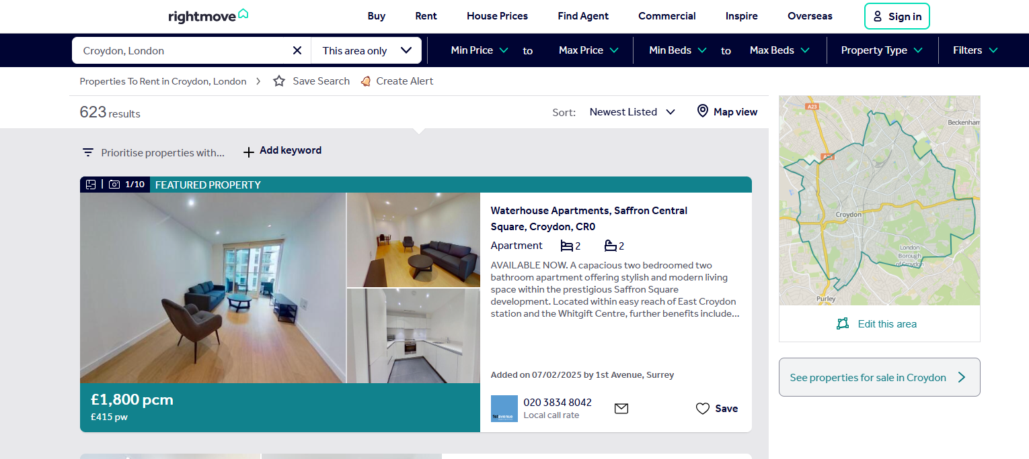
Property Type | Minimum | Median | Maximum
Flat
Detached house
…

Exercise 3: Business Tenants in London
Objective - Develop a methodology (no need to write any specific code) to identify and list all tenants occupying warehouse buildings visible on Google Maps (or equivalent mapping platforms) for a particular submarket, such as Tower Hamlets. This allows Valor to understand the tenant profiles for a particular market.
This task tests your ability to structure a real-world, ambiguous data problem with clear thinking and creativity.

